EsperantiloTM

Quick Tutorial

Artur Trzewik mail@xdobry.de

Enhavo
Introduction 2
Installation 2
Basic idea of the program 2
Creation of a translation project 2
Translation 3
Usage of Translation Memory 5
Saving and reopening of translation projects 6
Finishing the project 6
Project Esperantilo 6
Processing of XLIFF-files 6
Differences to program OmegaT 7
Author and License 7

Introduction
EsperantiloTM is a program for translators which uses a translation memory for facilitating the translation of documents. EsperantiloTM is in principle limited program Esperantilo, which contains only functions of translation memory. About program Esperantilo read more on htt://www.esperantilo.org.
That document intends to describe the basic functions of program EsperantiloTM.

Installation
There is an installation program EsperantiloSetup.exe for Windows operating system. The program can be also used on Linux

Basic idea of the program
The translator's task is to translate some document from a source language to a target language. The translator receives that document usually from some another author. The result of a translation work is the target document, which has the same appearance and a format, but its contents is in the target language.
EsperantiloTM supports this process The program remembers additionally every translated sentence in so called translation memory. If a translator will face the same or a similar sentence, the program shows the last translation of that sentence. The translator does no have to translate the same sentences again and again or he can reuse parts of translated sentences.
The program analyses the source document and extracts from it only texts. The text is separated in segments. The segment is usually one sentence. A translator does not have to care about an appearance (formatting) of the text.
After when the whole text (every segment) is translated, the program can create the target document. It is the translated document.

Creation of a translation project
After a launch of the program one can define a new translation project. For this one have to define the source document (click the symbol of a folder for choosing the source file), a the source language and the target language. The program creates also one file as translation project. This file has the extension „.espts“. In that file there are informations about a progress of the translation project.
Do not remove the source document. You need the source document to create the target document after the translation.
EsperantiloTM accepts documents in following formats:
- OpenOffice documents
- HTML-Dokumentoj
- XML-Dokumentoj
- Pure text documents
- MS Word documents (only on Windows, if MS is Word installed)
You can use the program OpenOffice to convert documents of an another type to OpenOffice documents.
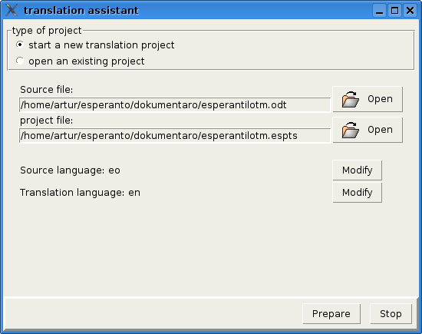Image 1: Creation of a new translation project

Translation
One translates segment after segment. The segment contains usually one sentence. One can edit only one segment at giving time.
One can navigate between segments, define a translation or remove the translation.
The Symbols "" are used for to make visible separators of formatting areas. Those separators exists, if exists words with special formatting in source text.

The program contains also a spell checker. The spelling is checked during accepting of the translation. If some unknown word exists, then that word is underlined in red. If one wants but to accept that translation, accept the translation simply again.
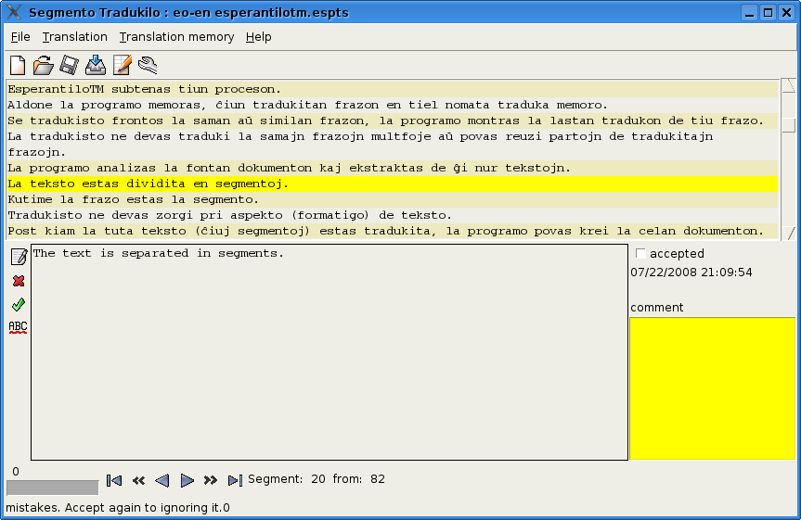Image 2: Segment editor - translation of segments

The segments contain also addition informations. It is:
- The author of a translation
- Time of a last modify
- comment
- Acceptance check box
Those informations can used for multi level testing of translation quality and collaborative work of many translators on one translation project.

Usage of Translation Memory
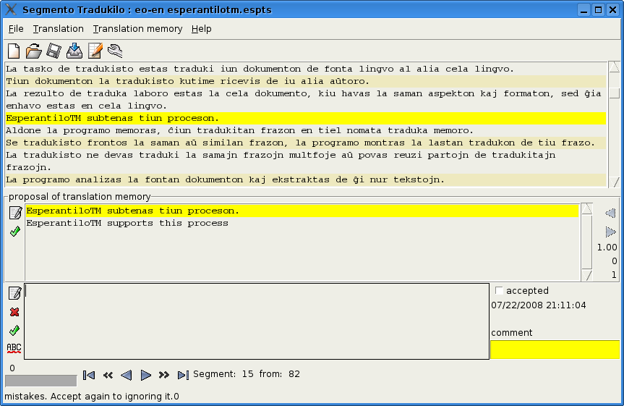Image 3: Segment editor - suggestion from the translation memory
One can edit also the translation memory. Use menu: Translation memory>Editor of Translation Memory. There are functions for exporting and importing translation memories in TMX format.

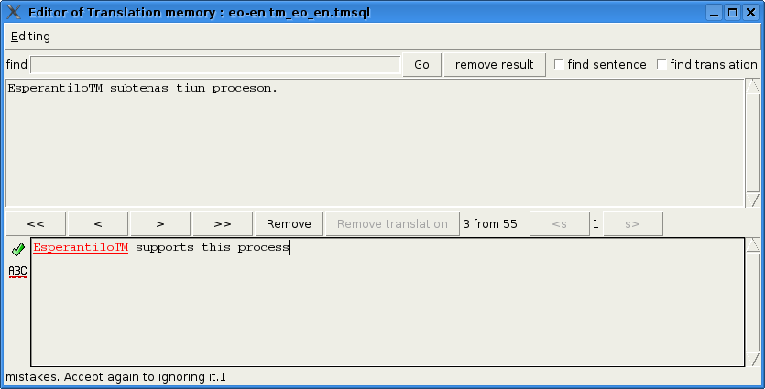Image 4: Translation Memory Editor

Saving and reopening of translation projects
The translations are immediately conserved in the file. But you can use the conservation with a menu: File>Save. At lunching time of EsperantiloTM you can find your recent translation project immediately in the list or you can load the project file from file dialog. The translation project file has the extension „espts“.
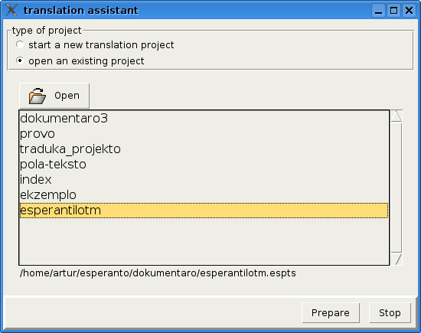Image 5: Opening of recent translation project

Finishing the project
When every segments are translated, one can create the target document. Use the menu for this: File>Export translation to file. One can do several time, also if the text is not finally translated.

Project Esperantilo
EsperantiloTM is a part of the program Esperantilo. That program is done particularly for Esperanto language. The program Esperantilo contains addition functions:
- Grammar checker} for Esperanto language
- Simple text editor
- dictionaries
- machine translation between languages: eo->pl, en, de, sv, pl->eo, en>eo.

Processing of XLIFF-files
EsperantiloTM can process XLIFF-files. You can open that file as project file.

Differences to program OmegaT
OmegaT is very good free a program with similar functions but there are some differences between EsperantiloTM and OmegaT.
- Translation project contains an only source document in EsperantiloTM
- The translation memory is not link with some translation project, but there is translation memory for every language pair.

Author and License
The program EsperantiloTM is written as amateur project by Artur Trzewik. Contact address: mail@xdobry.de
published according to FGPL license is that document. It is a free license for documents. The program is published according to GPL license.

